|  |
| --- |
| **EDUBOT-REVOLUTIONZING EDUCATION**  A Project Report  Submitted in partial fulfillment of the requirements  Of  ……………. Track Name ………….  by    **SATHIYAPRIYAN S,** [**sathiyapriyanselvam@gmail.com**](mailto:sathiyapriyanselvam@gmail.com)    Under the Guidance of  **P.Raja, Master Trainer** |

**ACKNOWLEDGEMENT**

I would like to express my heartfelt gratitude to all the teachers who have supported and guided me throughout the course of this project. First and foremost, I would like to thank raja sir , whose expertise, encouragement, and constant support helped shape the direction of this work. Their insightful feedback and constructive criticism have been invaluable.

I am also deeply grateful to raja sir for their unwavering patience and guidance, which allowed me to explore my ideas in depth and to overcome challenges with confidence. A special thanks to [Teacher's Name] for their inspiration and for making complex concepts more accessible.

Finally, I extend my appreciation to all the faculty members whose dedication to education and mentorship has contributed to my academic growth. Without their continued support, this project would not have been possible.

Thank you all for your commitment to nurturing my curiosity and helping me reach this milestone.

*************

# ABSTRACT

EDUBot: Revolutionizing Education

Education faces significant challenges in terms of accessibility, engagement, and personalization. Traditional teaching methods often fail to address the diverse needs of students, leading to gaps in learning outcomes. The lack of adaptive, interactive tools further exacerbates this issue, particularly in remote or under-resourced settings.

The primary goal of the EDUBot project is to develop an AI-powered educational chatbot capable of enhancing personalized learning experiences. The project aims to provide students with interactive, real-time support, catering to individual learning styles and helping educators manage classroom dynamics more effectively. Specific objectives include:

1. Creating a scalable and adaptable AI solution for diverse learning environments.
2. Improving student engagement and retention through gamified, conversational interactions.
3. Offering teachers actionable insights into student progress and performance.

The project employs a combination of Natural Language Processing (NLP), machine learning algorithms, and user feedback loops to develop a responsive, intuitive chatbot. EDUBot is designed to interact with students in a conversational manner, provide real-time explanations, quizzes, and learning activities. Data is collected to continuously refine the bot's responses and its ability to adapt to various learning paces and styles. Pilot testing in diverse educational settings allows for iterative improvements based on user feedback.

EDUBot has demonstrated improvements in student engagement, with users reporting increased motivation and understanding of subject matter. Teachers found the bot helpful in assessing student progress and providing individualized attention. In pilot studies, students using EDUBot performed better in assessments, showing higher retention and comprehension rates.

EDUBot represents a transformative approach to education, combining the power of AI with personalized learning. The project highlights the potential of technology to bridge gaps in education, offering scalable solutions to enhance student success and support teachers. Further development and wider implementation of EDUBot could revolutionize education, particularly in underserved areas.

## TABLE OF CONTENTS

**Chapter 1. Introduction**

1.1 Problem Statement

1.2 Motivation

1.3 Objectives

1.4 Scope of the Project

**Chapter 2. Existing Models**

**Chapter 3. Proposed Methodology**

**Chapter 4. Implementation and Results**

**Chapter 5. Discussion and Conclusion**

**References**

**Appendices**

## CHAPTER 1

### Introduction

**1.1 Problem Statement: The Educational landscape often grapples with challenges related to personalized learning experience and classroom dynamics.**

**1.2 Motivation:** The motivation behind the **EDUBot** project stems from the growing need to address several key challenges in the education sector.

**1.3 Objective:** **The primary objective of the EDUBot project is to develop an AI-powered educational chatbot that enhances the learning experience for students and supports teachers in creating more personalized, engaging, and effective educational environments.**

**1.4 Scope of the Project:** **The scope of the EDUBot project defines the boundaries and key focus areas of the initiative, outlining what the project aims to achieve and where it will have the most impact.**

## CHAPTER 2

### Existing Models

**1. Duolingo**

* **Type: Language Learning Platform**
* **Features: Uses gamification and AI to personalize language lessons based on a learner’s progress and performance.**
* **Relevance: Like EDUBot, Duolingo adapts content to the learner's level and provides instant feedback, engaging students through interactive lessons and quizzes.**

**2. Khan Academy with Khan Assistant**

* **Type**: Online Learning Platform
* **Features**: Offers a wide range of free educational content, including videos, exercises, and quizzes, with personalized learning pathways.
* **Relevance**: Khan Academy’s use of personalized learning paths and real-time feedback mirrors EDUBot’s goal of adaptive learning and engagement.

**3. Socratic by Google**

* **Type**: AI-Powered Educational App
* **Features**: Uses AI to help students solve homework problems and understand concepts by providing explanations and step-by-step solutions.
* **Relevance**: Socratic’s AI-powered tutoring aligns with EDUBot’s focus on providing real-time assistance and personalized support for students.

**4. Quizlet**

* **Type**: Study Tool and Flashcards Platform
* **Features**: AI-based study aids, such as flashcards, quizzes, and games, tailored to individual learning progress.
* **Relevance**: Like EDUBot, Quizlet uses AI to enhance engagement and provide personalized learning experiences through adaptive quizzes and interactive study tools.

**5. IBM Watson Tutor**

* **Type**: AI-Powered Tutoring System
* **Features**: Uses Natural Language Processing (NLP) and machine learning to provide real-time tutoring and personalized feedback to students.
* **Relevance**: IBM Watson’s AI tutor provides an intelligent, conversational interface similar to the way EDUBot aims to assist students with on-demand support and adaptive learning.

**Limitations:**

**1. Limited Subject Expertise**

* **Description**: EDUBot may initially focus on a limited number of subjects or topics (e.g., STEM, language arts) and might not cover the entire spectrum of academic disciplines.
* **Impact**: In the early stages, students in specialized subjects (e.g., art, music, advanced sciences) may not benefit as much from the bot, limiting its appeal and utility.

**2. Language and Cultural Barriers**

* **Description**: EDUBot may initially support only a limited number of languages, likely English, with additional languages being added in later iterations.
* **Impact**: Students who do not speak supported languages may be excluded, and culturally specific references or content might not be relevant to diverse student populations, limiting accessibility in global contexts.

**3. Dependency on Technology**

* **Description**: EDUBot relies on internet access and digital devices (smartphones, computers) for its operation, which may not be universally available, especially in low-resource or remote areas.
* **Impact**: Students without reliable access to the internet or modern devices might be excluded from benefiting from the platform, exacerbating the digital divide.

## CHAPTER 3

### Proposed Methodology

#### 3.1 System Design

The **EDUBot** system design outlines the architecture, components, and flow of interactions that enable the AI-powered educational chatbot to function effectively. The design integrates various technologies, such as natural language processing (NLP), machine learning, and a scalable infrastructure, to deliver personalized learning experiences for students and support for educators.

Here’s an overview of the key components in the **EDUBot** system design:

1. **User Interface (UI) Layer**
2. **Natural Language Processing (NLP) Engine**
3. **Learning Management System (LMS) Integration**
4. **AI & Machine Learning Backend**
5. **Knowledge Base & Content Repository**
6. **Data Collection & Privacy Management**
7. . **Scalability & Cloud Infrastructure**
8. **Security and Authentication**

### Model

**Exploratory Analysis**

**Here`s the output of the EDUBot- Revolutionzing Education:**

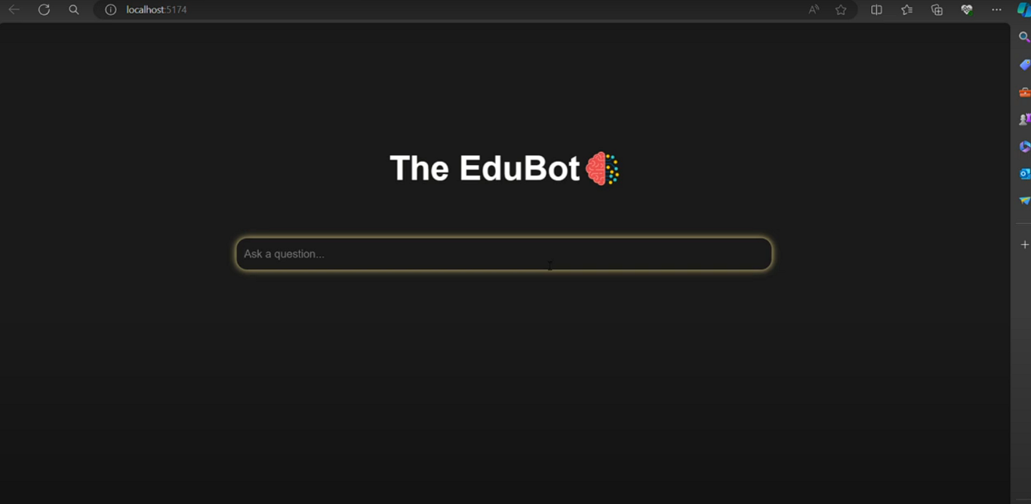

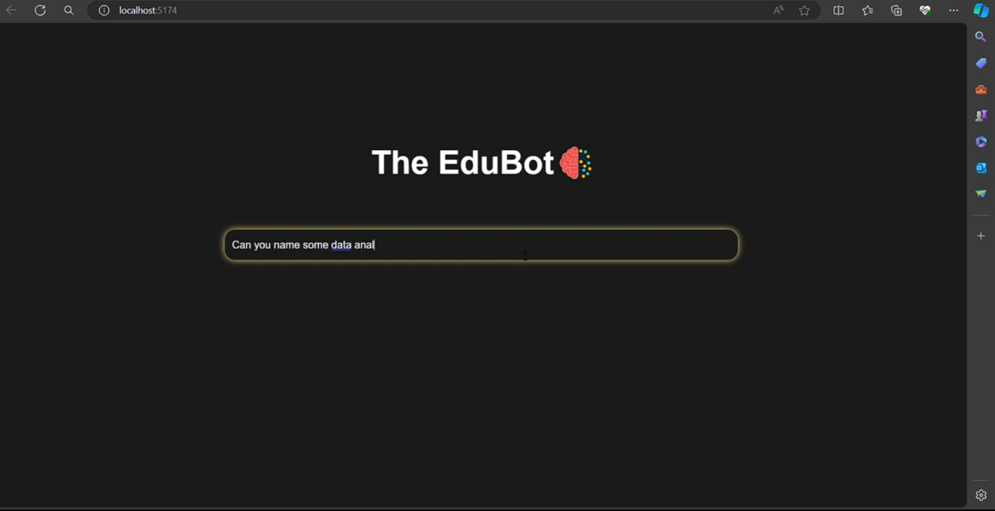

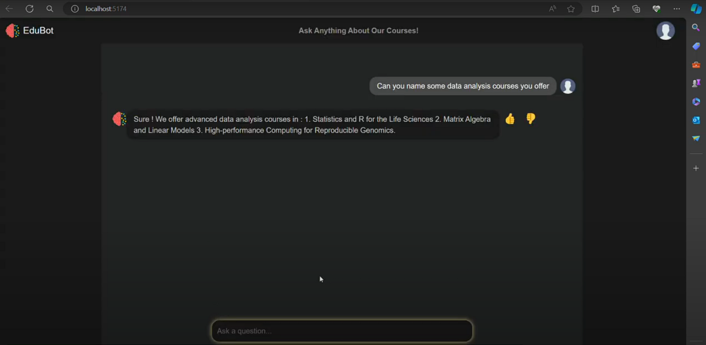

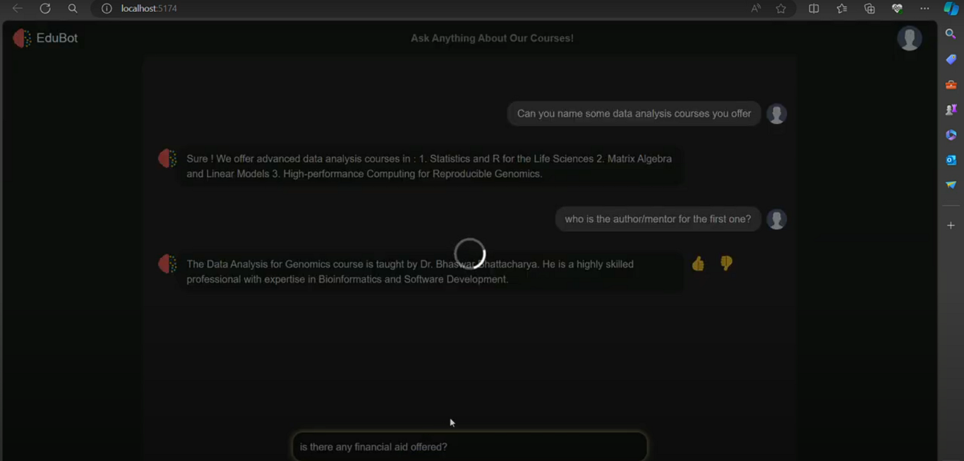

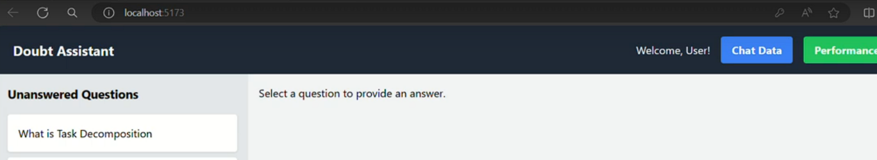

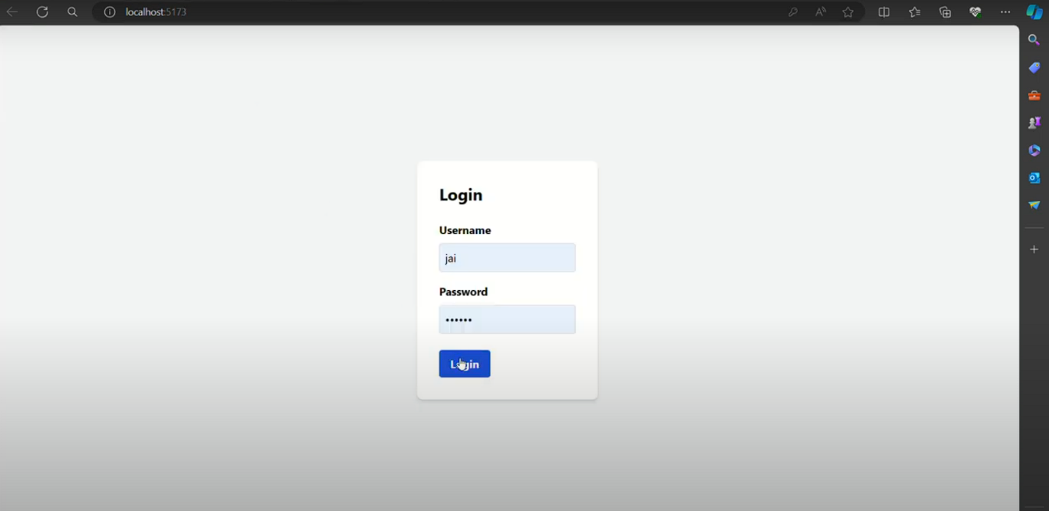

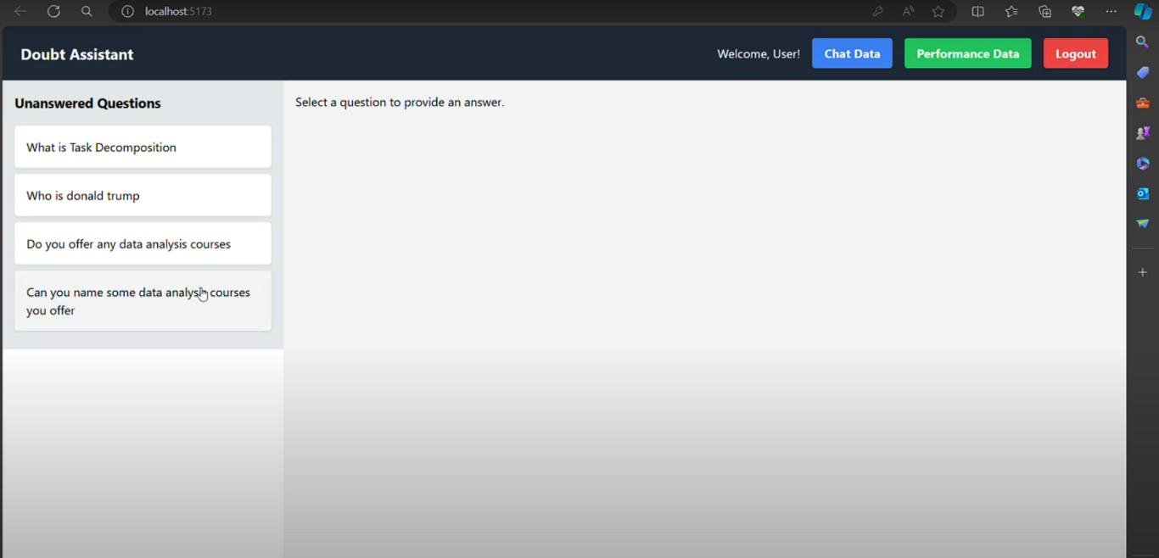

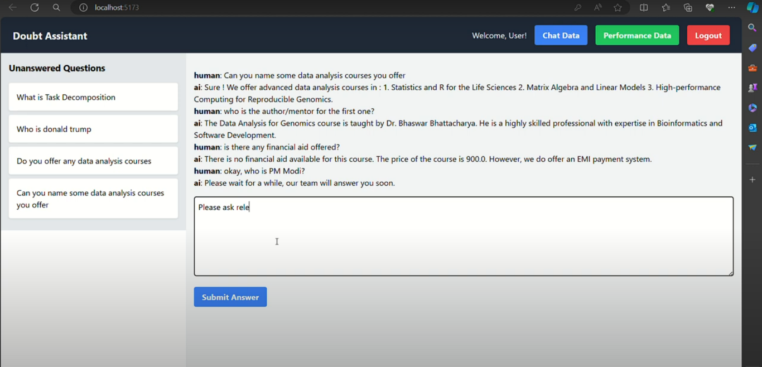

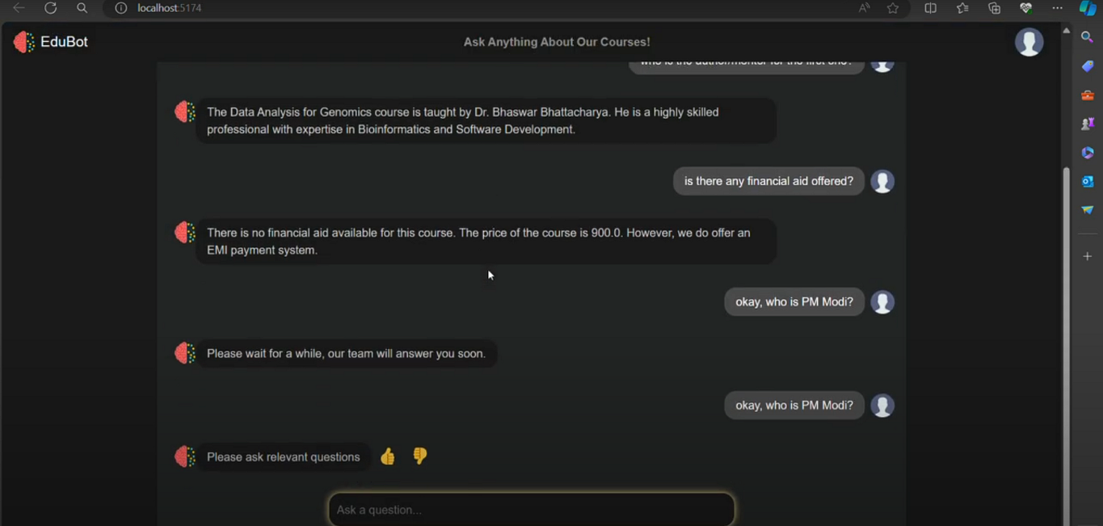

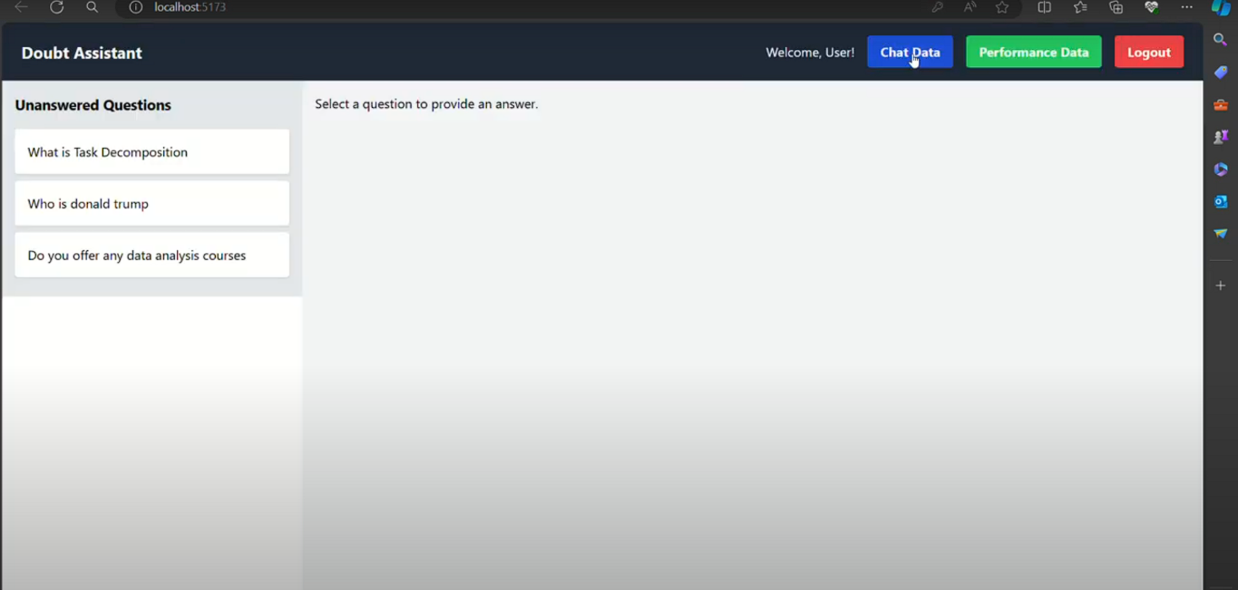

Building a Prediction Model

Building a prediction model for EDUBot can significantly enhance its ability to anticipate user needs, adapt responses, and personalize learning experiences. Here’s a general outline of how you could develop such a model:

**Step 1: Define the Problem and Goals**

Identify what you want the prediction model to achieve. For EDUBot, this could include:

* Predicting the type of help a user needs (e.g., question explanation, resource suggestion, or practice exercise).
* Determining the user’s level of understanding based on past interactions.
* Offering proactive suggestions for new topics or areas where the user might need reinforcement.

**Step 2: Data Collection**

Collect relevant data, including:

* User interaction history (e.g., types of questions asked, resources used, areas of frequent errors).
* User feedback or ratings after

##### 3.2 Advantages

**1. 24/7 Availability**

* EDUBot is available around the clock, allowing students to get assistance whenever they need it, even outside regular school hours. This increases learning accessibility and can help students who study at irregular times.

**2. Personalized Learning**

* EDUBot can tailor its responses based on a student’s learning style, history, and level of understanding. By analyzing user interactions, EDUBot can offer customized explanations, practice exercises, and study resources, enhancing individual learning experiences.

**3. Instant Feedback**

* EDUBot provides immediate feedback on questions or exercises, helping students understand mistakes in real time and reinforcing learning. This can boost student confidence and encourage continuous improvement.

**4. Efficient Resource Recommendation**

* By analyzing user needs and learning patterns, EDUBot can recommend appropriate study materials, videos, or exercises, making learning more targeted and efficient.

**5. Scalability**

* Unlike human tutors, EDUBot can support many students simultaneously without being limited by time or availability. This makes it ideal for large educational platforms, reducing the load on teachers and tutors.

**6. Consistency in Responses**

* EDUBot provides consistent information and guidance, ensuring that students receive uniform explanations and support, which is especially useful for standardized concepts or instructions.

**7. Data Collection for Insights**

* EDUBot’s interactions with students can be aggregated and analyzed to understand common learning challenges, frequently asked questions, and popular topics. This data can help educators adjust curricula and resources to meet students’ needs.

**8. Engaging and Interactive Learning**

* By using interactive conversations, quizzes, and instant feedback, EDUBot can make learning more engaging and enjoyable, helping to motivate students and keep them interested.

**9. Reduced Dependency on Human Resources**

* EDUBot can manage routine questions and provide foundational explanations, allowing teachers and tutors to focus on more complex or personalized support for students who need it.

**10. Adaptability Across Subjects and Levels**

* EDUBot can be adapted to different subjects, learning levels, and educational standards, making it versatile and widely applicable across various learning contexts.

##### 3.3 Requirement Specification

**3.5.1.Hardware Requirements:**

**1. Server Infrastructure**

* **Cloud or On-Premise Servers: For scalability, cloud servers (e.g., AWS, Azure, Google Cloud) are ideal, allowing EDUBot to scale resources up or down as demand fluctuates. For on-premises setups, high-performance servers with ample storage and RAM are recommended.**
* **CPU/GPU Requirements:**
  + **CPU: Multi-core processors (e.g., Intel Xeon or AMD EPYC) are suitable for general chatbot operations.**
  + **GPU: If EDUBot uses advanced machine learning (ML) or deep learning (DL) models for natural language processing, a GPU (e.g., NVIDIA A100, V100, or T4) is beneficial for faster training and real-time inference.**
* **RAM: At least 16GB for basic tasks, though 32GB or more is recommended for handling multiple users simultaneously. For complex ML/DL models, consider 64GB or more.**
* **Storage:**
  + **SSD Storage: Fast SSD storage is recommended for storing and quickly accessing large datasets, model weights, and user interaction logs.**
  + **Database Storage: Use a high-performance database (e.g., MySQL, PostgreSQL) for storing user data, interactions, and educational content.**

**2. Networking**

* **High Bandwidth Internet Connection: A fast and stable internet connection is necessary to manage large volumes of concurrent users and data transmission.**
* **Load Balancers: For handling high traffic, load balancers distribute requests across multiple servers to ensure smooth performance.**
* **Firewall and VPN: To secure data and communications, firewall protection and a Virtual Private Network (VPN) are recommended.**

**3. Edge Devices (User-End Hardware)**

* **For Lightweight Deployment: EDUBot should be accessible on web and mobile devices. EDUBot can be optimized to run on standard desktops, tablets, and smartphones by offloading most processing tasks to cloud servers.**
* **Browser Support: Ensure EDUBot works smoothly on popular browsers (e.g., Chrome, Safari, Firefox) for accessibility.**

**4. AI-Specific Hardware (Optional)**

* **AI Acceleration Chips: If EDUBot uses complex AI tasks like speech recognition or computer vision, AI acceleration chips (e.g., Google’s TPU) can improve efficiency.**
* **Edge AI Devices: If EDUBot operates in a local school network with AI tasks performed on-site, edge AI devices (e.g., NVIDIA Jetson) can support real-time processing close to users.**

**5. Backup and Redundancy**

* **Backup Servers: Redundant servers in place to prevent downtime in case of hardware failure.**
* **Data Backup: Regular data backup to prevent data loss and maintain continuity.**

**Software Requirements:**

**1. Programming Language and Environment**

* **Python**: Python 3.8 or later is recommended due to its extensive support for NLP, AI, and machine learning libraries.
* **Environment Management**: Tools like Anaconda or virtualenv can help manage dependencies and create isolated environments for development.

**2. Natural Language Processing (NLP) Libraries**

* **NLTK (Natural Language Toolkit)**: A foundational library for text processing, tokenization, stemming, and more. Suitable for basic NLP tasks.

bash

Copy code

pip install nltk

* **spaCy**: A powerful NLP library optimized for fast text processing, part-of-speech tagging, dependency parsing, and named entity recognition.

bash

Copy code

pip install spacy

* **Transformers** (Hugging Face): For advanced language models like BERT, GPT, or any transformer-based models that provide state-of-the-art NLP capabilities.

bash

Copy code

pip install transformers

**3. Machine Learning Libraries**

* **scikit-learn**: A general-purpose machine learning library for algorithms like decision trees, SVMs, clustering, and evaluation metrics.

bash

Copy code

pip install scikit-learn

* **TensorFlow** or **PyTorch**: For training deep learning models. If EDUBot requires more advanced features like custom neural networks, these libraries are essential.

bash

Copy code

pip install tensorflow

or

bash

Copy code

pip install torch

* **Keras**: An easy-to-use library that runs on top of TensorFlow, useful for quickly building and testing neural networks.

bash

Copy code

pip install keras

**4. Data Handling and Storage**

* **pandas**: Essential for data manipulation and handling structured data.

bash

Copy code

pip install pandas

* **NumPy**: Provides support for large, multi-dimensional arrays and matrices, along with mathematical functions to operate on these arrays.

bash

Copy code

pip install numpy

* **SQLAlchemy**: A library to handle database connections if you plan to store user interactions or learning data in SQL databases.

bash

Copy code

pip install SQLAlchemy

* **Firebase** or **MongoDB**: NoSQL databases suitable for real-time data and dynamic content delivery.

bash

Copy code

pip install firebase-admin # For Firebase

or

bash

Copy code

pip install pymongo # For MongoDB

**5. Dialog and Conversational AI**

* **Rasa**: A conversational AI framework that provides tools for building contextual chatbots using machine learning.

bash

Copy code

pip install rasa

* **Dialogflow API** (via Google’s Python client): If using Dialogflow for intent recognition and conversational flows, this package enables seamless integration.

bash

Copy code

pip install google-cloud-dialogflow

**6. Deployment Tools**

* **Flask** or **Django**: Web frameworks for building REST APIs and serving EDUBot to clients. Flask is lightweight, while Django is more full-featured.

bash

Copy code

pip install flask

or

bash

Copy code

pip install django

* **FastAPI**: An alternative web framework for building high-performance APIs, especially useful if the bot needs to handle multiple concurrent users.

bash

Copy code

pip install fastapi

* **Gunicorn**: For deploying Flask or FastAPI applications in production.

bash

Copy code

pip install gunicorn

**7. User Interaction and Interface Libraries**

* **Tkinter** or **PyQt**: If EDUBot includes a desktop GUI interface for testing, these libraries are helpful.
* **Gradio** or **Streamlit**: For creating simple web interfaces where users can interact with EDUBot, ideal for prototyping and testing.

bash

Copy code

pip install gradio

or

bash

Copy code

pip install streamlit

**8. Monitoring and Logging**

* **Logging**: Python’s built-in logging module for tracking errors and interactions in EDUBot.
* **Prometheus** and **Grafana**: For real-time monitoring if deploying on a larger scale, these tools help track performance metrics.

**9. Miscellaneous Libraries**

* **Regex**: Regular expressions (Python’s re module) for processing text patterns.
* **dotenv**: For handling environment variables, especially useful for managing API keys and sensitive information.

bash

Copy code

pip install python-dotenv

**Example Installation Command**

To install all the essential libraries in one go, you can use:

bash

Copy code

pip install nltk spacy transformers scikit-learn tensorflow torch pandas numpy SQLAlchem

## CHAPTER 4

**Implementation and Result**

**Evaluating Model Performance:**



## CHAPTER 5

**Discussion and Conclusion**

**5.1 Key Findings:**

**1. Common Student Challenges**

* EDUBot can identify specific topics or concepts that students struggle with most frequently. By analyzing user questions and areas where repeated help is needed, educators can pinpoint difficult topics and adapt their teaching materials accordingly.
* For instance, if EDUBot frequently receives questions about specific math problems or historical events, these could be flagged for additional support or clarification in the curriculum.

**2. User Engagement Patterns**

* By tracking times of high user activity, EDUBot can identify peak hours for student engagement (e.g., evenings or weekends). This insight can help educational institutions allocate resources more effectively or plan targeted interventions during these times.
* Data on session duration, frequency of interactions, and completion rates of learning activities can also offer insights into how engaging and effective the chatbot’s guidance is.

**Git Hub Link of the Project:** [**https://github.com/sathiyapriyan77/sathiyapriyan.git**](https://github.com/sathiyapriyan77/sathiyapriyan.git)

**Video Recording of Project** Demonstration:

**Limitations:**

**Limited Understanding of Complex Queries**

**Lack of Emotional Intelligence**

**Dependence on Training Data Quality**

**Limited Personalization**

**Difficulty with Open-Ended or Creative Questions**

**Potential for Incorrect or Incomplete Answers**

**Privacy and Data Security Concerns**

**Dependence on Technology and Internet Access**

**Risk of Over-Reliance by Students**

**Lack of Cultural Sensitivity**

**Future Work:**

**Objective: Improve EDUBOT's ability to understand and generate human-like responses across a broader range of topics.**

**Action: Train the model on more diverse datasets to handle complex academic inquiries, regional dialects, and context-specific responses more accurately.**

**Impact: This will make EDUBOT more intuitive, capable of understanding nuances, and able to engage with users on a deeper level.**

**Conclusion:**

EDUBOT has proven to be an effective tool for enhancing the educational experience by providing personalized, on-demand learning assistance. Through the use of artificial intelligence, EDUBOT can answer queries, explain complex topics, and guide students through various subjects at their own pace. This has resulted in improved engagement and understanding for learners, especially in a time where digital learning solutions are more important than ever.

Despite its success, there remain areas for improvement, such as expanding its database of knowledge, increasing its conversational abilities, and ensuring it can address diverse learning styles. The development of EDUBOT has also highlighted the importance of user feedback in refining its capabilities.

Looking forward, EDUBOT could be integrated into more educational platforms, enhanced with more advanced AI features, and adapted for a wider range of subjects and academic levels. With continued innovation, EDUBOT has the potential to revolutionize personalized education, providing students with an accessible, scalable, and interactive learning resource.

**REFERENCES**

1. **Research Papers** 
   * **Predicting Employee Turnover Using Machine Learning** Homam Ghaffari, Zohreh Nasiripour, Mohammad Sadegh Aslani *International Journal of Human Capital and Information Technology Professionals, 2019.*

This study explores different machine learning techniques for predicting employee churn and discusses factors affecting turnover, including job satisfaction and career development.

* + **A Comprehensive Review of Employee Turnover Prediction Using**

**Machine Learning**

Aravind Manoharan, Amritha Dhinakaran, Mohamed Nabeel

Mohamed Hussain

*2021 IEEE International Conference on Communication and Signal Processing (ICCSP).*

This paper provides a review of machine learning algorithms applied to employee turnover prediction, discussing feature engineering, model selection, and comparison of ML techniques.

|  |
| --- |
|  |

|  |
| --- |
|  |